IWDW tools
Emissions Review Tool (ERT): Generates “dynamic” charts of annual emissions for WAQS modeling platforms. Data are aggregated to state and county levels. Pollutants are grouped by chemical species and source categories. County level source categories can be displayed by Source Classification Codes (SCCs).
Model Performance Evaluation Plots (Image Browser): Browser to display “static” AMET generated plots generated by the WAQS modeling group for modeling platform MPE. Plots include boundary conditions analyses, meteorological modeling, emissions, and PGM results. Plot types include spatial, time series, bar, soccer, scatter plots, etc. Spatial aggregations include 4 and 12km domains. Temporal aggregations include annual and monthly averages, with hourly, 1hr max, 8hr max comparisons at monitoring sites with continuous criteria pollutant monitoring.
Model-to-Observation Comparison Tool (Model-to-Obs): Dynamic display of PGM output paired to observational data. Pairings can be aggregated by observational network. Time series charts can be filtered by date range. The tool provides comparisons of modeling results at monitoring sites that may not be available in the MPE plot browser.
MPE Metrics: Prototype tool to display tabular results from PGM MPE. Table can be selected for desired metric and sorted by output values.
Monitoring Data Tools (Reports): Includes pre-defined charts for visibility, O3, wet and dry deposition.
Source Apportionment Tool (SA): Dynamic charts to visualize SA modeling results. 2008b based SA includes source category specific contribution to MDA8 at monitoring sites (in 4km DSAD and by States and regions in 12km domain). 2011a based SA visualization tool includes Round 1 (R1) geographic, and source category (R2) based visualization tools.
GIS Tools: Two emissions GIS prototypes are under development: One shows chemical parameter specific emissions magnitudes by county. The UI enables selection/deselection of additional states. The ability to add spatial layer overlays, and spatial analysis is under consideration. The second emissions GIS shows state or county level emissions by chemical parameter and allows source category and SCC drill down via an interactive pie chart.
Other GIS tools being considered for development include: Selection of geographic regions (e.g. monitoring site, county and other areas of interest) as a user interface (UI) to enable data selection for the tools listed above. This type of is used for the state/county pie chart GIS described above, however could be extended to other IWDW tool for area (e.g. region of interest) or point (e.g. monitoring site) selection. Another application for a GIS tool is to produce “layered” displays of either gridded and/or point data, including model output and observational data. Such a tool could be used to create dynamic spatial aggregations of model output.
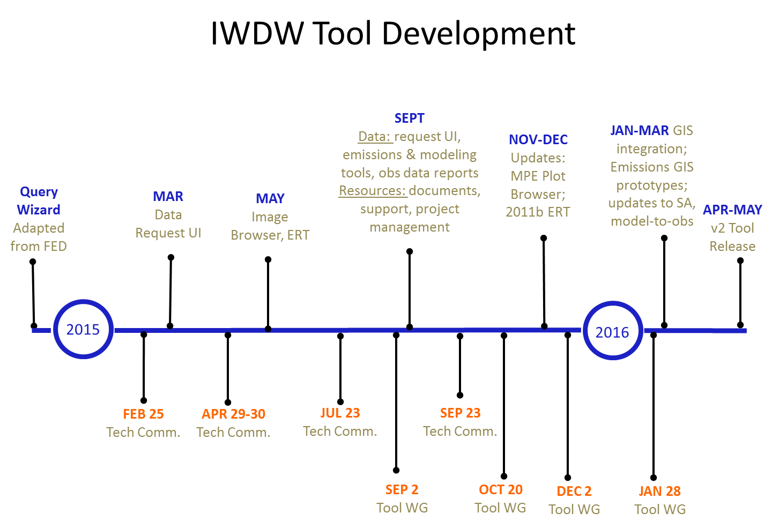

Figure 1. IWDW tool deployment timeline
Table 1. IWDW tool development and deployment planning
Tool | Version | Current functionality & future enhancements | Modeling platforms | Obs. data | Target release date
ERT | v1 | Dynamic browsing of 3SAQS/WAQS emissions data at chemical parameter, source category, state, county, and SCC levels. Displays stacked bar charts; tabular data at SCC level | 2008b, 2020-08b  2011 Base, 2011b, 2025-11b |  | 9-23-15
 | v2 | Enhancements: Source category and parameter aggregation metadata; multiple platform display; charts at SCC level; refactor State ordering; speciated VOCs (need to address sectors w/o VOC speciation, e.g. biogenics. Could apply to anthro sources with VOC speciation)  Bug fixes: SCC max query string; multiple platform selection; select box text truncation; 2018-11 has no data;  Clean up ambiguous platform names. |  |  | TBD
MPE Plots | v1 | Display of static images used for WAQS modeling platform MPE. Includes met, emissions, and PGM plots for release platforms and related sensitivity studies | Base 2008b, Base 2011a, 2011a_GCBC, 2011a_MOVES, 2011a_WinterO3, Base 2011b Met Winter03, Base 2011b, 2011WRF, 2014 WRF  (Base 11b includes 2025 EMIS tileplots) |  | 9-23-15
 | v1.1 | UI update and support for new image file naming convention | Base 2011b CMAQ; 2025_11b AQ CAMx and CMAQ |  | Pending release of 2011b base and future case modeling
 | v2 | Enhancements: dual plots, metadata enabled plot selection; daily emissions spatial plots for speciated VOCs; batch plot download |  |  | TBD
MPE Metrics | v1 | Sortable table of aggregated (e.g. by state, domain and/or season) MPE metrics. | 2011b CAMx, CMAQ |  | TBD
 | v2 | Expand to site level metrics |  |  | TBD
Model-to-obs | v1 | Dynamic time series plots of model-to-obs data pairings generated using AMET and sitecompare.f  UI updates | 2008b | AQS, CASTNet, CSN, IMPROVE | 9-23-15
 | v2 | Enhancements: map based site selection; additional chart types (scatter, spatial stats, tile plots, soccer); statistics output (r2, NME, NMB, etc.); State ordering; filtering for diurnal trends | 2011a, 2011b (CAMx, CMAQ) |  | TBD
SA | v1  (v1.0.1.2) | Current: Source category specific contribution to MDA8 at monitoring sites (in 4km DSAD and regions in 12km domain) | 2008b |  | 9-23-15
 | v2 | 2011 R1, R2 | 2011a |  | TBD
 | v3 | 2011 R3 | 2011 CAMx “Clean” runs |  | TBD
Summary reports (general) | v1 | pre-defined displays of observational data; single-site selection using Google map UI |  |  | 9-23-15
 | v2 | GIS based single/multiple site selection; select sites by other criteria (e.g. proximity to geographic regions –CIAs, urban/rural characteristics, elevation, O&G basin proximity)
Visibility | v1 | RHR metrics (are these relevant to IWDW-WAQS?) |  | IMPROVE dv | 9-23-15
 | v2
Ozone | v1 | Trends, exceedances |  | AQS hourly | 9-23-15
 | v2 | Enhancements: apply 70ppb O3 standard
Wet Dep | v1 | S, N trends and composition |  | NADP NTN | 9-23-15
 | v2
Dry Dep | v1 | S, N trends and composition |  | CASTNet | 9-23-15
 | v2 | Enhancements: add PM, Hg dep
Other reports? |  | Phase I, Phase II O&G inventories and projections
 |  | WAQS O&G sectors vs. NEI
GIS tools | v1 | Prototypes: Emissions GIS - One shows chemical parameter specific emissions magnitudes by county. The second shows state or county level emissions by chemical parameter and allows source category and SCC drill down via an interactive pie chart. Allows only one pie chart per state/county or state/county group.  GIS layers for overlays:  - APCD: Resources from State of CO  - EPA Greenbook: Boundaries for national NAAs (O3 & PM)  - WAQS O&G activity; Development project boundaries if available  - Class I, II Area boundaries  Geographic selection UI could be applied to ERT, as tools are driven by the same database, hence county/state data resolution. |  |  | Prototype
 | V2 | Emissions: Include gridded emissions with user defined spatial analysis  PGM MPE: combine PGM output and monitoring data layers

Green text indicates planned tool updates

